Welcome to DevOps Training.
As a begineer to the you need to create an account in AWS in order to proceed with the lab practice.
Following are the list of setups you need to perform.

a. Create AWS Account.

1. You need to create an account by opening the following URL and click on "Sign in to Cosole"
http://aws.amazon.com
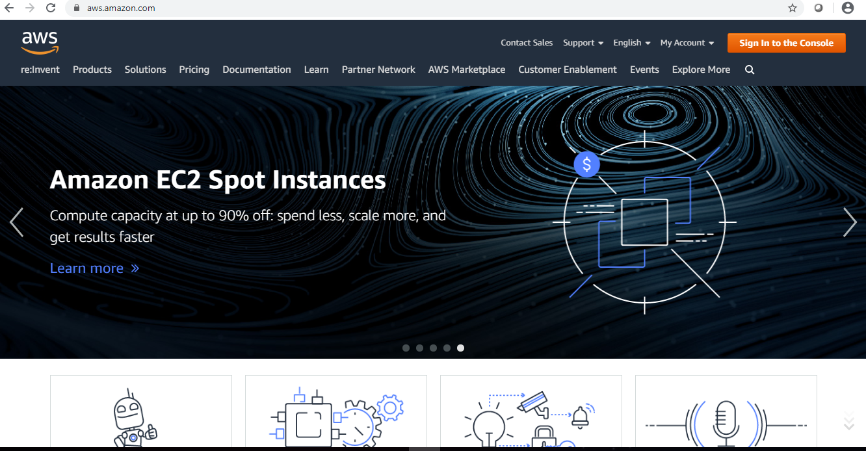

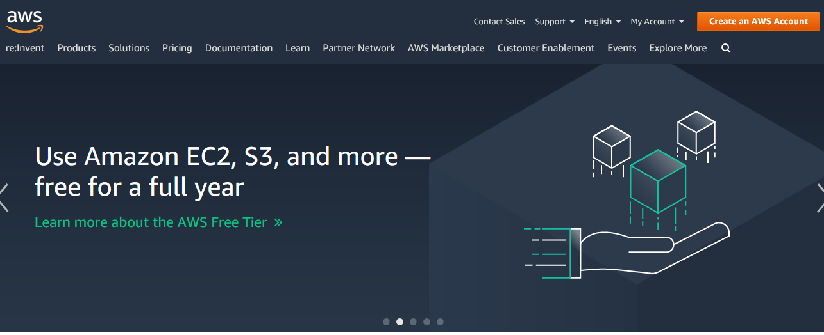

2. Click on “Create a new AWS account”
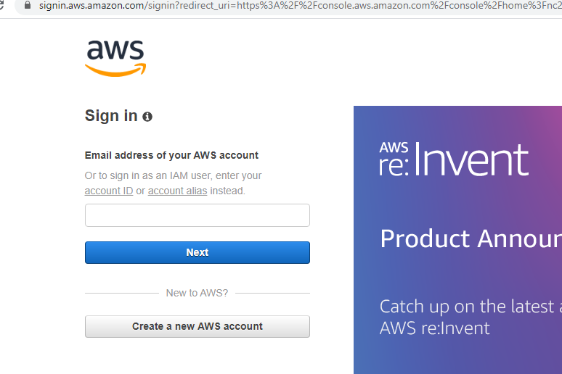

3. Fill your details to create an account. Details required are Email address and your account name of your choice.
Click on “Continue”.

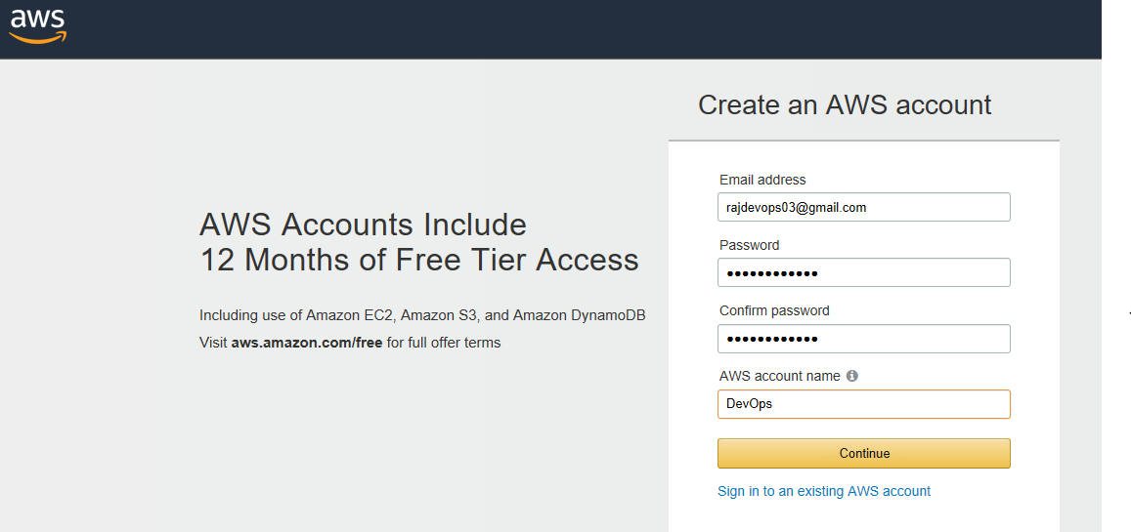

4. After submitting the data you will be taken to SignUp form which requires more details.
i. Select Account Type as `Personal`
ii. Your address and Mobile number. (Need to provide a valid mobile number, You will recive a call in further setup)

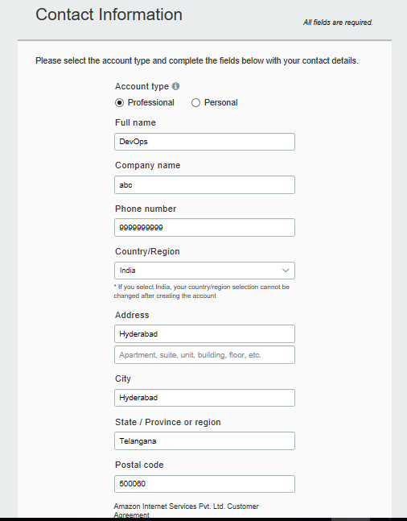

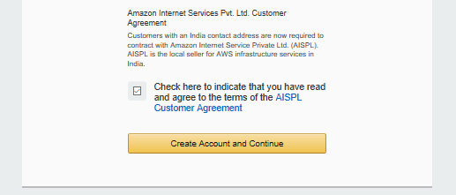

5. Next you will be prompt to provide the credit card details. So proceed by providing the details
i. Provide credit/debit card details.
ii. Select PAN number as NO
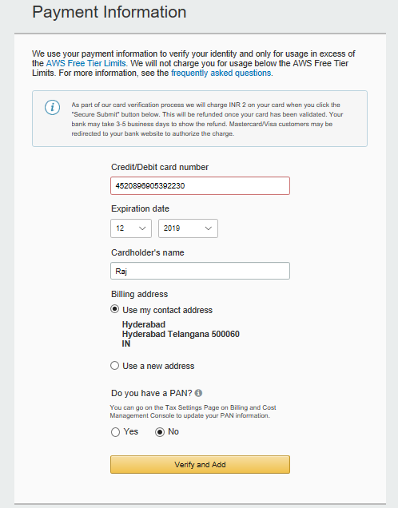

5. You will be redirected to your bank payment portal to provide OTP and after that select the plan as Basic.

6. Once after your account creation is completed then use the following link to open your account.
http://console.aws.amazon.com
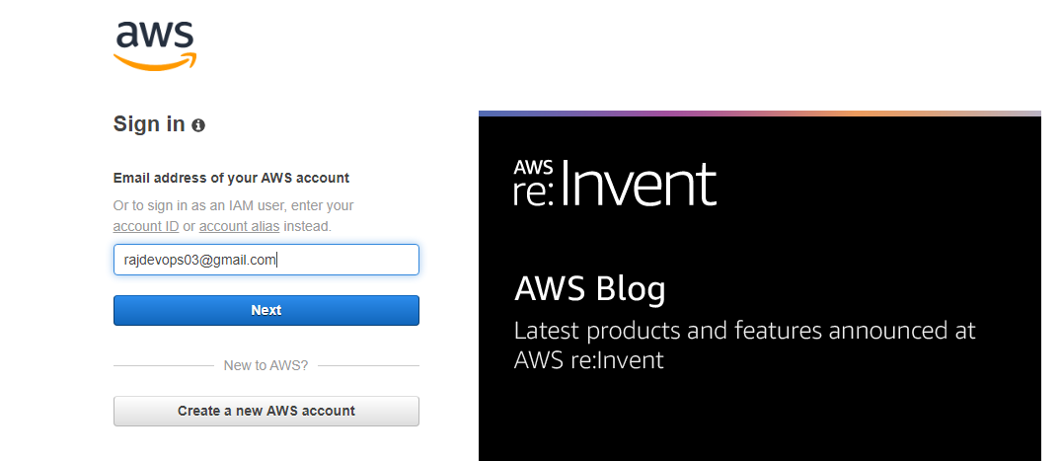

Getting Started
When you first access the AWS Management Console for your account, the home page will look something like below. The different sections of the AWS Console home page are portals through which you can navigate to AWS services, solutions, and learning resources, as well as to third-party tools in the AWS Marketplace.

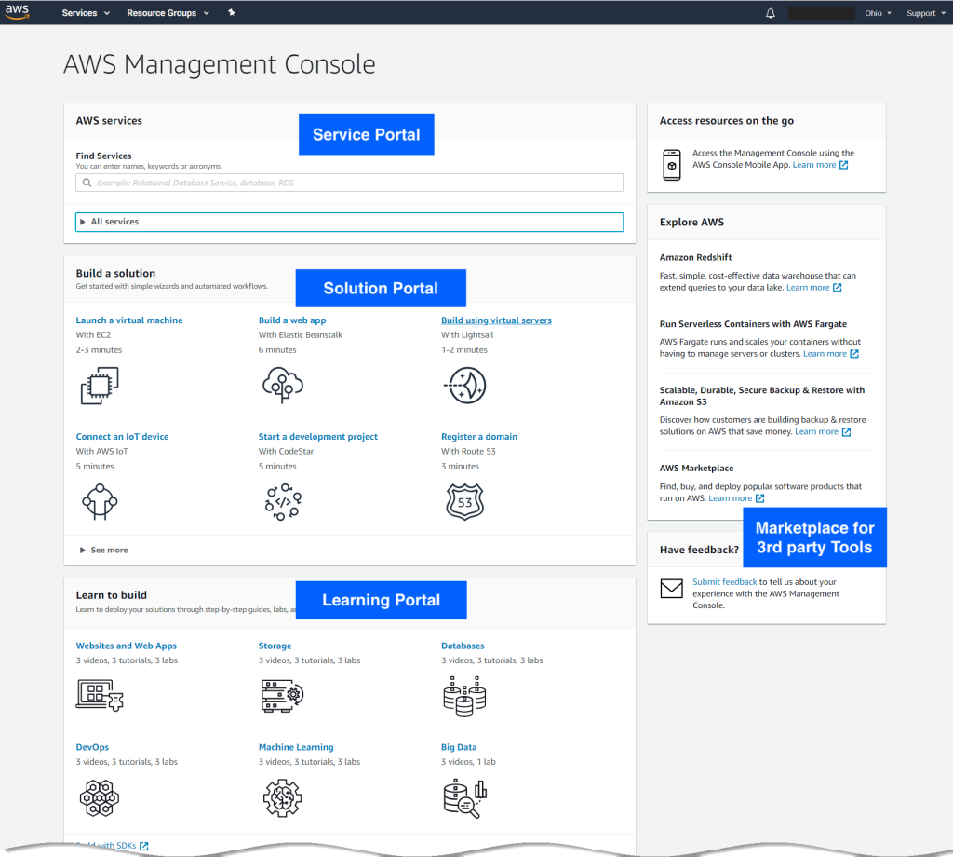

Services
From the AWS Management Console, you can access the consoles and dashboards of the various services you are using in your AWS deployment. In this section, we describe how to navigate to a service, and we look at a typical service console using IAM as an example.

Navigating to a Service

There are a number of ways that you can navigate to a service dashboard from the AWS Management Console.

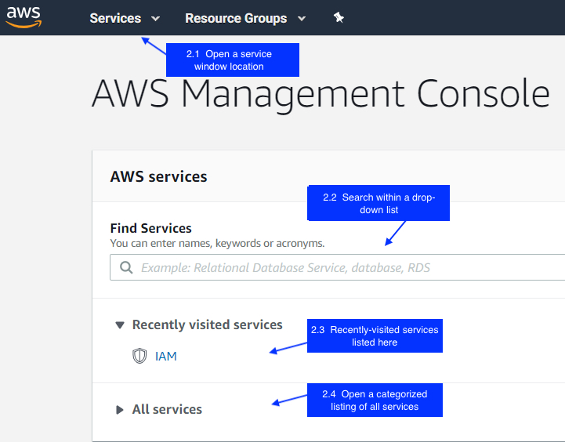

You can click Services in the navigation bar to open a service location window as shown in below image.

There you can..
A. Conduct a text search for a service.
B. Choose to view the services grouped in categories or in alphabetical order.
C. See a history of recently visited service consoles

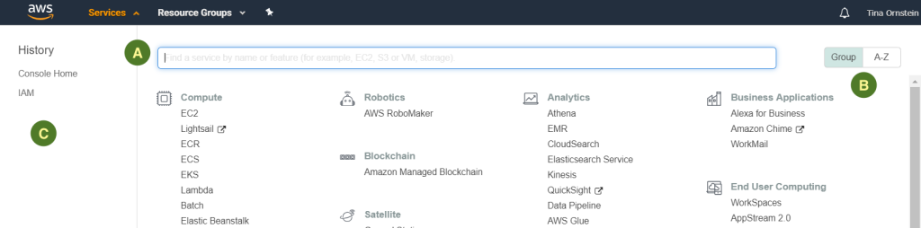

You can also click inside the Find Services text box to open a drop-down alphabetized list of all services, and then either scroll to the desired service or use text search to narrow down the list.

